|  |
| --- |
| **MESGEN.pngBCA Protein Assay Kit** |

**Catalog Number :** MG1002

**Packaging Size :** 500 / 1000 tests

**Introduction**

The BCA Protein Assay combines the well-known reduction of Cu2+ to Cu1+ by protein in an alkaline medium with the highly sensitive and selective colorimetric detection of the cuprous cation (Cu1+) by bicinchoninic acid. The first step is the chelation of copper with protein in an alkaline environment to form a light blue complex. In this reaction, known as the biuret reaction, peptides containing three or more amino acid residues form a colored chelate complex with cupric ions in an alkaline environment containing sodium potassium tartrate. In the second step of the color development reaction, bicinchoninic acid (BCA) reacts with the reduced (cuprous) cation that was formed in step one. The intense purple-colored reaction product results from the chelation of two molecules of BCA with one cuprous ion. The BCA/copper complex is water-soluble and exhibits a strong linear absorbance at 562 nm with increasing protein concentrations. The BCA reagent is approximately 100 times more sensitive (lower limit of detection) than the pale blue color of the first reaction. The reaction that leads to BCA color formation is strongly influenced by four amino acid residues (cysteine or cystine, tyrosine, and tryptophan) in the amino acid sequence of the protein. However, unlike the Coomassie dye-binding methods, the universal peptide backbone also contributes to color formation, helping to minimize variability caused by protein compositional differences.

**Highlights**

Compatible – Unaffected by typical concentrations of most ionic & nonionic detergents

Moderately fast – Much easier and four times faster than the classical Lowry method

High linearity – Linear working range for BSA equals 20 to 2000µg/mL

**Kit Contents**

|  |  |  |
| --- | --- | --- |
| Component | 500 rxn | 1000 rxn |
| BSA Standard (1 mg/mL) | 4 mL | 8 mL |
| BCA Reagent A | 100 mL | 200 mL |
| BCA Reagent B | 2 mL | 4 mL |

**Test method in 96-well plate**

**Step 1** BCA work solution prepared by mixing Reagent A / Reagent B = 50 / 1 ( volume ratio)

**Step 2** Drawing the standard curve

|  |  |  |  |  |  |  |  |  |
| --- | --- | --- | --- | --- | --- | --- | --- | --- |
| No. | 0 | 1 | 2 | 3 | 4 | 5 | 6 | 7 |
| BSA Standard (µL) | 0 | 1 | 2 | 4 | 8 | 12 | 16 | 20 |
| H2O (µL) | 20 | 19 | 18 | 16 | 12 | 8 | 4 | 0 |
| BCA work solution (µL) | 200 | 200 | 200 | 200 | 200 | 200 | 200 | 200 |
| Protein content (µg) | 0 | 1 | 2 | 4 | 8 | 12 | 16 | 20 |

After oscillating mixing, then place at 37°C for 30min. OD values at 562nm obtained from microplate reader. Then set the protein content as abscissa and absorbance value as ordinate. Drawing the standard curve.

**Step 3** Sample detection

20µl sample protein solution added into 200ul BCA work solution, place at 37°C for 30min. Then get the OD values at 562nm of sample solution. According the above standard curve, protein content then is confirmed.

**Step 3** Calculation of sample protein concentration

Sample protein concentration = Protein content / Sample volume

**Notice**

Substance concentration limit interfering the BCA method

|  |  |
| --- | --- |
| Glucose | 10 mM |
| Octyl glucoside | 5.0% |
| Sodium acetate | 200 mM |
| Sucrose | 40% |
| Ammonium Sulfate | 1.5 M |
| Brij-35 | 5.0% |
| CHAPS | 5.0% |
| DTT | 1 mM |
| EDTA | 10mM |
| Emulgen | 1.0% |
| Glycine | 100 mM |
| Guanidine•HCl | 4.0 M |
| HEPES | 100 mM |
| Lubrol | 1.0% |
| NaOH | 0.1 M |
| NP-40 | 5.0% |
| SDS | 5.0% |
| Sodium Chloride | 1.0M |
| TritonX-100 | 5.0% |
| Urea | 3.0 M |

**Storage condition**

Reagent A / B at 4°C

BSA Standard at -20°C

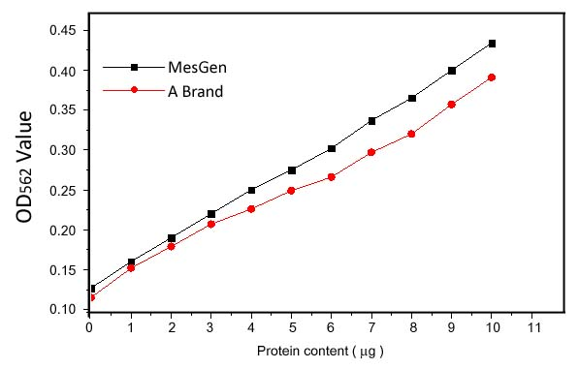

Figure 1. Compared with the types of products



***For Research Only***