Mitomycin C from Streptomyces caespitosus
# MG1308
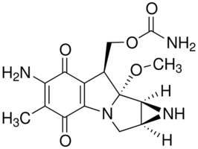
Product Name : Mitomycin C Cat.No. MG1308
Formulation : Powder CAS : 50-07-7
MW : 334.33 Purity : ≥ 97%
Solubility: Soluble in H₂O Storage : Store at 2-8°C in the dark

Application
Mitomycin C is used to generate mitotically inactive feeder cells used in cell culture systems, such as mitotically inactive fibroblast used in embryonic stem cell (ESC) systems.

General description
Mitomycin C is an anti-neoplastic antibiotic, DNA inter-strand, cross-linking, alkylating agent that targets guanine nucleoside in the sequence 5′CpG-3′. It produces oxygen radicals and is preferentially toxic to hypoxic cells.

Cat.No. | Product Name | Package | List price
MG1308-100MG | Mitomycin C | 100MG
MG1308-500MG | Mitomycin C | 500MG

For Research Use Only. Not Intended for Diagnostic or Therapeutic Use.

