JC-1 Mitochondrial Membrane Potential Dye
# MG9621
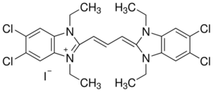
Product Name: JC-1 Mitochondrial Membrane Potential Dye
Cat.No. MG9621 Lot No. 20140111MGJ
Formulation : Solid CAS : 3520-43-2
MW : 652.23 Purity : ≥95%
Solubility: Soluble in DMSO Storage : Store at -20°C

Application
A dual-emission potential-sensitive probe that can be used to measure mitochondrial membrane potential. JC-1 is a green-fluorescent (λex=515 nm) monomer at low membrane potential. At higher potentials, JC-1 forms red-fluorescent (λem=585 nm ) "J-aggregates," which exhibit broad excitation and very narrow emission spectra. The ratio of red to green fluorescence of JC-1 is dependent only on membrane potential, and not influenced by mitochondrial size, shape, or density.

Recommended work concentration

1-20ug/mL

Product including
Cat.No. | Name | Package | List price
MG7989-500UG | JC-1 (Soild) | 500UG | 760
 | DMSO | 10ML | 0
MG7989-1MG | JC-1 (Soild) | 1MG | 1400
 | DMSO | 20ML | 0

For Research Use Only. Not Intended for Diagnostic or Therapeutic Use.

