MesGen Biotechnology Co.,Ltd.
Tel: 86-21-56620378
E-mail :info@mesgenbio.com
www.mesgenbio.com

Quality Certificate
NC Membrane Filter | Cat Number:MG92345-1PAC
 | Lot Number:150710024M

ISO 9001 Quality Standard
The product was manufactured in the Membrane Solutions facility whose Quality Management System is approved by an accredited registering body to the ISO 9001 Quality Systems Standard.

Membrane Filter Lot Characterization
Filter Media | NC | Wettability | Hydrophilic
Color | White | Thickness(μm) | 120-150
Pore Size(μm) | 0.22 | Bubble Point (psi) | 61-87
Size(mm) | 300*3000 | Flow Rate(ml/min/cm²@10psi) | 6.5-12.5
Bubble point and Flow rate are tested by water at 25℃.

HPLC Extractables Test (254nm)
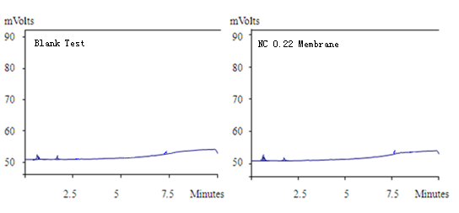
Specification | Result
No detectable peaks | Pass

