|  |
| --- |
| **MESGEN.pngMetformin hydrochloride** |

**Cat.No #** MG8775 **Lot.No :** Refer to Vial

**Packaging :** 1g & 5g & 10g

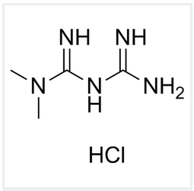**Synonym :** Metformin hydrochloride

**CAS number :**1115-70-4

**Formula :**C4H11N5, HCl

**Molecular weight :** 165.6

**Solubility :** 100 mM in water

**Purity :** >98%

**Solubility :** water (50 mg/ml), ethanol (<1 mM) and DMSO (<1 mM).

**Working concentration :** 2 - 10 mM

Application

A antihyperglycemic biguanide which stimulates AMPK.

**Description**

Metformin activates adenosine monophosphate-activated protein kinase (AMPK), an enzyme that controls cell survival, mediates cell activation and metabolism. Metformin is used as an antidiabetic drug and displays significant growth inhibitory effects in several cancer models. Experimental data indicate that metformin blocks lymphoma cell growth through the inhibition of the mTOR pathway and the induction of autophagy.

**Store condition**

Metformin is provided as a solid and shipped at room temperature. Store at 4°C. Solid product is stable 2 years when properly stored. Upon resuspension, prepare aliquots of metformin and store at -20°C. Avoid repeated freeze-thaw cycles. Resuspended product is stable for 1 month when properly stored.

**For Research Use Only. Not for use in diagnostic procedures.**

