|  |
| --- |
| **MESGEN.pngLuminol** Biotechnology Grade |

**Cat.No #** MF7883 **Lot.No :** Refer to Vial

**Packaging :** 5g & 25g

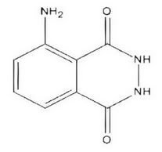**Synonym :** 3-Aminophthalhydrazide

**CAS number :**521-31-3

**Formula :**C8H7N3O2

**Molecular weight :** 177.16

**Purity :** >98%

Application

A chemiluminescence generating reagent for biological and metal cation assays

**Description**

Luminol is a reagent for the generation of chemiluminescence in biological assays including nitric oxide and myeloperoxidase assay. Luminol is converted to a dianion in basic solution, which is then oxidized with H2O2/Cu2+to form N2 and an aminophthalate ion in an electronically excited state. The aminophthalate ion emits a photon of wavelength 424 nm.

**Store condition**

-20°C.

**For Research Use Only. Not for use in diagnostic procedures.**

