Anti-V5 Tag Mouse Monoclonal Antibody
Technical literature is available at: www.mesgenbio.com. E-mail MesGen Technical Services if you have questions on use of this system: tech@mesgenbio.com

Catalog Number : MAN2005 Lot Number : Refer to vial Packaging Size : 100μL□200μL□500μL□1000μL□

Background
Anti V5-tag antibody can recognize C-terminus, internal, and N-terminus V5-tagged proteins.
Overview
Description : Mouse monoclonal antibody to V5-Tag [2F10]
Tested applications : WB(1:500-1:5000), IP(1:50-1:200),IF(1:50-1:500) Formulation : Liquid
Properties
Immunogen : GKPIPNPLLGLDST (V5 epitope) conjugated with KLH.
Clonality : 2F10 Isotype : Mouse IgG1
Application notes
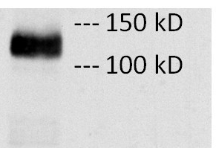

Fig. Lane : 3T3 cells transfected with V5-tagged protein vector diluted at 1: 1000.

Optimal working dilutions should be determined experimentally by the investigator.
Storage instruction
Store at +4°C short term (1-2 weeks).
Aliquot and store at -20°C or -80°C
Note: The product listed herein is for research use only and is not intended for use in human or clinical diagnosis. Suggested applications of our products are not recommendations to use our products in violation of any patent or as a license. We cannot be responsible for patent infringements or other violations that may occur with the use of this product.
Distributor in China ( Mainland )
Company : Shanghai hongsheng Biotechnology Co.,ltd
Address : Room 2-205, Xingzhan building, No.185, Liuying Road, Zhabei District, Shanghai
Tel : 86-21-56620378 Fax : 86-21-56620378
Email : sales@hongshengbio.com Website : www.hongshengbio.com

