SB216763 Package : 10mg
Technical literature is available at: www.mesgenbio.com. E-mail MesGen Technical Services if you have questions on use of this system: tech@mesgenbio.com
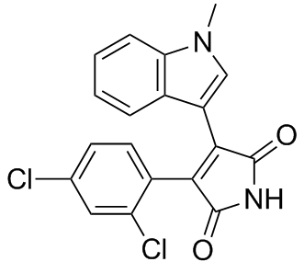
Catalog Number : MG29903
Appearance : Off-white to orange(solid)
Molecular weight : 371.22
CAS : 280744-09-4
Purity ≥98% by HPLC
Molecular formula : C₁₉H₁₂Cl₂N₂O₂

Description
A cell-permeable (arylindole) maleimide compound that acts as a potent, selective, ATP-competitive inhibitor of GSK-3 activity (K_{i} = 9.1 nM for GSK-3α). At 10 µM concentration, does not significantly inhibit a panel of 24 other protein kinases tested. Reported to stimulate glycogen synthesis in Chang human liver cells (EC₅₀ = 3.6 µM) and induce transcription of β-catenin-LEF/TCF (lymphoid enhancer factor/T cell factor) regulated reporter gene in HEK293 human embryonic kidney cell lines. Offers protection against polyglutamine-induced death in SK-N-SH and COS-7 cells and attenuates hypoxia-induced apoptosis in VSMC and COS-7 cells. Shown to reduce phosphoenolpyruvate carboxykinase (PEPCK) and glucose-6-phosphatase (G6Pase) expression in hepatoma cells. Promotes the survival of CLL lymphocytes via Wnt/β-catenin-mediated transcription activation. Exhibits delayed cardioprotection in vivo in a rat model via a KATP (ATP-sensitive potassium channels) and MPTP (mitochondrial permeability transition pore)-dependent mechanism at reperfusion.
A cell-permeable (aryl,indole) maleimide compound that acts as a potent, selective, ATP-competitive inhibitor of GSK-3 activity (K_{i} = 9.1 nM for GSK-3α). At 10 µM concentration, does not significantly inhibit a panel of 24 other protein kinases tested. Reported to stimulate glycogen synthesis in Chang human liver cells (EC₅₀ = 3.6 µM) and induce transcription of β-catenin-LEF/TCF (lymphoid enhancer factor/T cell factor) regulated reporter gene in HEK293 human embryonic kidney cell lines. Offers protection against polyglutamine-induced death in SK-N-SH and COS-7 cells and attenuates hypoxia-induced apoptosis in VSMC and COS-7 cells. Shown to reduce phosphoenolpyruvate carboxykinase (PEPCK) and glucose-6-phosphatase (G6Pase) expression in hepatoma cells. Promotes the survival of CLL lymphocytes via Wnt/β-catenin-mediated transcription activation. Exhibits delayed cardioprotection in vivo in a rat model via a KATP (ATP-sensitive potassium channels) and MPTP (mitochondrial permeability transition pore)-dependent mechanism at reperfusion.

Solvent & Solubility
DMSO ≥25mg/mL Water <1.2mg/mL Ethanol <1.2mg/mL

Storage condition
-20°C
For Research Use Only. Not For Use In Diagnostic Procedures.

