Indocyanine Green MG87552
Technical literature is available at: www.mesgenbio.com. E-mail MesGen Technical Services if you have questions on use of this system: tech@mesgenbio.com
Packaging Size : 200mg □ 1g □
Lot Number : Refer to vial

Synonym : Cardiogreen, Foxgreen, IC Green, Indocyanine green
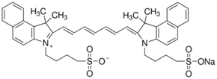
CAS : 3599-32-4
Formula : C43H47N2NaO6S2
Molecular Weight : 774.96
Beilstein Registry Number 4115884
MDL number MFCD00013078
Soluble in water (1 mg/ml), DMSO, methanol, and ethanol (less).

Biochem/physiol Actions
Cardiogreen is a cyanine dye which binds tightly to plasma proteins.

Storage condition
Room temperature

For Research Use Only. Not For Use In Diagnostic Procedures.

