Paclitaxel MTX1081
Technical literature is available at: www.mesgenbio.com. E-mail MesGen Technical Services if you have questions on use of this system: tech@mesgenbio.com
Packaging Size : 200mg □ 1g □
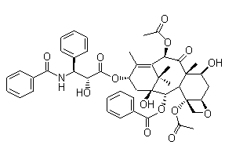
Lot Number : Refer to vial

CAS : 33069-62-4
Formula : C47H51NO14
Molecular Weight : 853.92

Solvent & Solubility
DMSO: ≥ 31 mg/mL; H₂O: < 0.1 mg/mL
Paclitaxel is dissolved at 20 mg/mL in DMSO and freshly diluted (1:1-1:200) as a suspension with PBS.
Paclitaxel is dissolved in DMSO, aliquoted and stored at -80°C until further use.

Biochem/physiol Actions
Paclitaxel is a potent anticancer agent known to promote microtubule (MT) assembly, inhibit MT depolymerization, and change MT dynamics required for mitosis and cell proliferation.

Storage condition
2-8 ºC

For Research Use Only. Not For Use In Diagnostic Procedures.

