2′,7′-Dichlorofluorescin diacetate MF2309
Technical literature is available at: www.mesgenbio.com. E-mail MesGen Technical Services if you have questions on use of this system: tech@mesgenbio.com

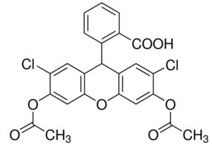
Synonym(s) : DCFH-DA
Appearance : Powder , White to White w/ Yellow Cast
Purity (TLC) ≥ 97.0%
CAS Number : 4091-99-0
Beilstein Registry Number : 4610273
MDL number : MFCD00128955
Molecular Weight : 487.29
Molecular Formula : C24H16Cl2O7
Ex (nm) : 504 Em (nm) : 529

Description
2′,7′-Dichlorofluorescin diacetate is a cell-permeable non-fluorescent probe. 2′,7′-Dichlorofluorescin diacetate is de-esterified intracellularly and turns to highly fluorescent 2′,7′-dichlorofluorescein upon oxidation.
Applications include sensitive and rapid quantitation of oxygen-reactive species in response to oxidative metabolism; microplate assay for detecting oxidative products in phagocytic cells, and quantitative multiwell myeloid differentiation assay.

Solvent & Solubility
DMSO: ≥ 150 mg/mL

Storage condition
−20°C

For Research Use Only. Not For Use In Diagnostic Procedures.

