Plant Anti-β-Actin Antibody
Technical literature is available at: www.mesgenbio.com. E-mail MesGen Technical Services if you have questions on use of this system: tech@mesgenbio.com
Catalog Number : MAN1011 Lot Number : Refer to vial Packaging Size : 100μL□1000μL□

Background
Plant beta Actin Mouse mAb detects endogenous levels of Actin protein in plants.
Overview
Description : Mouse monoclonal antibody to β-Actin [5G10]
Reactivity : Arabidopsis thaliana, Rice
Formulation : Liquid, 100 μg at 1mg/ml
Properties
Immunogen : Full-length beta Actin protein of Arabidopsis thaliana. Clonality : 5G10 Isotype : Mouse IgG1
Application notes
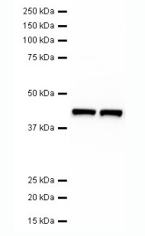

Fig. Western blot analysis of lysates from Arabidopsis thaliana (lane1) and Rice (lane2) with plant beta Actin mouse mAb (5G10 ). The antibody dilutions are 1:5000.

Tested applications : WB(1:1000-1:10000), Not yet tested in other applications.
Optimal dilutions/concentrations should be determined by the end user.

Storage instruction
Store at +4°C short term (1-2 weeks).
Aliquot and store at -20°C or -80°C

Note: The product listed herein is for research use only and is not intended for use in human or clinical diagnosis. Suggested applications of our products are not recommendations to use our products in violation of any patent or as a license. We cannot be responsible for patent infringements or other violations that may occur with the use of this product.

Distributor in China ( Mainland )
Company : Shanghai hongsheng Biotechnology Co.,ltd
Tel : 86-21-56620378 Fax : 86-21-56620378
Email : sales@hongshengbio.com Website : www.hongshengbio.com

