Anti-alpha-Tubulin Mouse Monoclonal Antibody
Technical literature is available at: www.mesgenbio.com. E-mail MesGen Technical Services if you have questions on use of this system: tech@mesgenbio.com

Catalog Number : MAN1008 Lot Number : Refer to vial Packaging Size : 100μL□1000μL□
Background
There are five tubulins in human cells: alpha, beta, gamma, delta, and epsilon. Tubulins are conserved across species. They form heterodimers, which multimerize to form a microtubule filament. An alpha and beta tubulin heterodimer is the basic structural unit of microtubules. The heterodimer does not come apart once formed. The alpha and beta tubulins, which are each about 55 kDa MW, are homologous but not identical. Alpha tubulin is useful for scientists across fields as an internal control due to its high, ubiquitous expression pattern. Tubulin expression may vary according to resistance to antimicrobial and antimitotic drugs. This antibody specifically recognizes Tubulin Alpha.
Overview
Reactivity : human, mouse, rat, dog, rice, silkworm Tested applications : WB, IP, IHC, IF, FC, ELISA
Calculated molecular weight : 50 kDa Observed molecular weight : 52 kDa
Properties
Immunogen : alpha Tubulin fusion protein Ag18034 Source : Mouse Isotype : IgG2b Concentration : 1730μg/ml

Recommended dilution:
WB : 1:2000-1:10000 IP : 0.5-4.0 ug for IP and 1:500-1:2000 for WB IHC : 1:50-1:500 IF : 1:50-1:500

Application notes
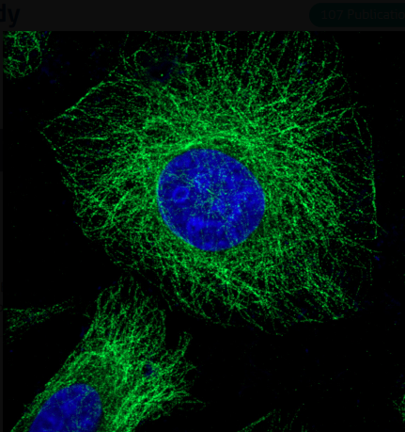
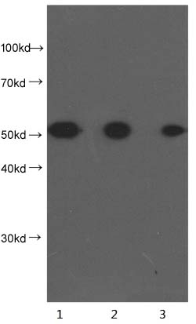

Fig 2. Immunoflurescent analysis of fixed HepG2 cells using alpha-Tubulin antibody at dilution of 1:100 and Alexa Fluor 488 conjugated AffiniPure Goat Anti-Mouse IgG(H+L)
Fig 1. Western blot analysis of 10ug of HeLa cell lysates at dilution of :
Lane 1: 1:4000
Lane 2: 1:8000
Lane 3: 1:16000

Storage instruction
-20°C

Note: The product listed herein is for research use only and is not intended for use in human or clinical diagnosis. Suggested applications of our products are not recommendations to use our products in violation of any patent or as a license. We cannot be responsible for patent infringements or other violations that may occur with the use of this product.

