Anti-DYKDDDDK tag Mouse Monoclonal Antibody
Technical literature is available at: www.mesgenbio.com. E-mail MesGen Technical Services if you have questions on use of this system: tech@mesgenbio.com

Catalog Number : MAN2008 Lot Number : Refer to vial Packaging Size : 100μL□1000μL□
Background
The DYKDDDDK peptide has been used extensively as a general epitope tag in expression vectors. This peptide can be expressed and detected with the protein of interest as an amino-terminal or carboxy-terminal fusion.
Overview
Description : Mouse monoclonal antibody to DYKDDDDK tag
Tested applications : WB :1/2000-1/10000. IHC:1/200-1/5000. ICC/IF:1/200-1/2000. IP : 1/100-1/500. Not yet tested in other applications. Optimal dilutions/concentrations should be determined by the end user.
Formulation : Liquid ,100 μg at 1mg/ml
Properties
Immunogen : Synthetic peptide DYKDDDDK conjugated to KLH Clonality : 3A6 Isotype : Mouse IgG2a
Application notes
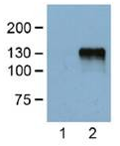
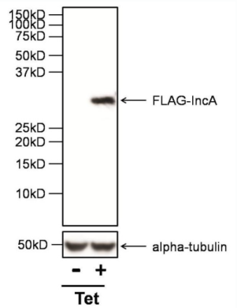
Fig. Lane 1: Untransfected control.Lane 2: HEK293 cells transfected with DYKDDDDK-tagged protein vector.Dilution at 1:5000.

Fig. WB: DYKDDDDK Epitope Tag Antibody - Analysis of 30ug of whole cell lysates from HeLa cells infected with a strain of Chlamydia trachomatis expressing FLAG-IncA under the control of a Tetracycline promoter (Tet), and either left untreated (-) or treated with anhydrotetracycline (+), onto an SDS-PAGE gel.

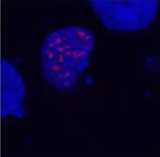
Fig. Immunofluorescence: DYKDDDDK Epitope Tag Antibody - Merged figures - confirmation of nuclear localization of the fusion protein; cell nuclei stained with DAPI (blue). COS-7 cells transfected with expression constructs encoding fusion nuclear protein with DYKDDDDK epitope. Fusion nuclear protein (red) stained with this antibody (detection by Goat anti-mouse IgG conjugated Alexa Fluor 594).

Storage instruction
Store at +4°C short term (1-2 weeks).
Aliquot and store at -20°C or -80°C
Note: The product listed herein is for research use only and is not intended for use in human or clinical diagnosis. Suggested applications of our products are not recommendations to use our products in violation of any patent or as a license. We cannot be responsible for patent infringements or other violations that may occur with the use of this product.

