硫酸多粘菌素B；多黏菌素 Polymyxin B Sulfate
Technical literature is available at: www.mesgenbio.com. E-mail MesGen Technical Services if you have questions on use of this system: tech@mesgenbio.com

Catalog Number : MG7213 Packaging Size : 1g & 5g
CAS : 1405-20-5
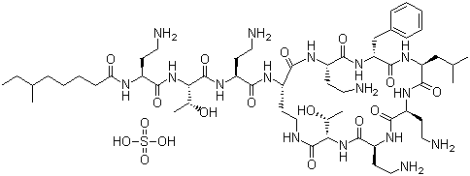
USP grade, ≥6,000 USP units/mg
Molecular Weight : 1301.56
Molecular Formula : C56H98N16O13·H2SO4
Synonym : Aerosporin, Polymyxin B Sulfate

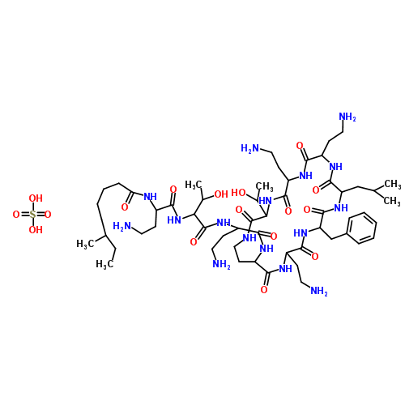
Description
An antibiotic that inhibits phospholipid-sensitive Ca2+-dependent protein kinases. Mixture of polymyxin B1 sulfate and polymyxin B2 sulfate. Binds to cell wall and makes it more permeable, causing fluid uptake. Effective against Gram-negative bacteria.

Primary Target
Phospholipid sensitive Ca2+ dependent protein kinases

Solubility
water: 25 mg/mL

Storage condition
2-8°C & Store in the dark

中文简介
多粘菌素系由多粘芽胞杆菌（bacilluspolymyxa）产生的一组多肽类抗生素。多粘菌素B和E供药用，常用其硫酸盐。硫酸多粘菌素B其抗菌谱及临床应用与多粘菌素E相似，对革兰阴性杆菌，如大肠杆菌、绿脓杆菌、副大肠杆菌、肺炎克雷白杆菌、嗜酸杆菌、百日咳杆菌及痢疾杆菌等有抑制或杀菌作用。

For Research Use Only. Not For Use In Diagnostic Procedures.

