4-异硫氢酸苯基-a-D-甘露糖苷
4-Isothiocyanatophenyl-a-D-mannopyranoside

Technical literature is available at: www.mesgenbio.com. E-mail MesGen Technical Services if you have questions on use of this system: tech@mesgenbio.com

Catalog Number : MG6753 Packaging Size : 50mg
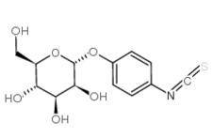
CAS : 96345-79-8
MDL : MFCD00070374
Purity ≥ 99% (HPLC)
- Molecular Weight : 313.33
Molecular Formula : C₁₃H₁₅NO₆S
Synonym : α-D-Mannopyranosylphenyl isothiocyanate

Description
α-D-Mannopyranosylphenyl isothiocyanate has been used in a study to assess the effect of antigen delivery using a novel mannosylated dendrimer. It has also been used in a study to improve gene delivery mediated by mannosylated dendrimer/α-cyclodextrin conjugates.

Storage condition
2-8°C

References
1. Woller EK, Cloniger MJ, Biomacromolecules 2001, 2, p1052
2. Roy R, Curr. Opin. Struct. Biol. 1996, Vol6, No5, p692-702

For Research Use Only. Not For Use In Diagnostic Procedures.

