For Research Use Only. Not For Use In Diagnostic Procedures
USER GUIDE MesGen Biotechnology
Version 2.0
阿利新蓝染色试剂盒
Alcian Blue Staining Kit

Cat.No. MAS0981
Size :2×100ml
Technical literature is available at: www.mesgenbio.com. E-mail MesGen Technical Services if you have questions on use of this system: tech@mesgenbio.com
Description
Alcian Blue is a dye used to detect cell chondrogenesis and it stains the sulfated proteoglycan in cartilage tissue. The Alcian Blue Staining Kit contains 1% Alcian Blue Solution, 0.1% Nuclear Fast Red in convenient, ready-to-use solutions. At pH 2.5, Alcian Blue stains acid mucopolysaccharides and shows a blue color, while Nuclear Fast Red stains nuclei pink to red and the cytoplasm pale pink.
Composition
1% Alcian Blue Solution | 100ml
0.1% Nuclear Fast Red | 100ml
Procedure
1. Fix the cells with 10% buffered formalin for 10 min at room temperature.
2. Rinse the slides in 1X PBS, stain with Alcian Blue solution for 30 min at room temperature.
3. Wash the slides in running tap water for 5 min, rinse in pure water.
4. Counterstain in Nuclear Fast Red solution for 5 min at room temperature.
5. Wash slides three times in pure water.
6. Gradient elution using ethanol, then Xylene transparent 5-10min, and sealed by Neutral gum.

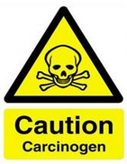

Do not eat Store at +2 to +8° C & in the dark.

操作说明（中文）
- 将切片至于10%中性福尔马林固定液中，室温固定处理10分钟；
- 用1X PBS清洗切片，再放入Alcian blue染色液中，室温染色30分钟；
- 将切片置于流水中，清洗5分钟；
- 将切片放入核固红染色液复染5分钟；
- 将切片置于流水中，清洗5分钟；
- 梯度乙醇脱水，二甲苯透明，中性树胶封片；
- 观察染色结果；
染色结果
酸性黏蛋白（硫酸黏蛋白和唾液黏蛋白） | 蓝色
蛋白多糖和透明质酸 | 蓝色
细胞核 | 红色
备注：若要选择性鉴别硫酸黏蛋白和蛋白多糖，应使用pH =1.0 的阿利新蓝染色，即调pH 值为1.0。染色时间可根据染色深度做相应调整。
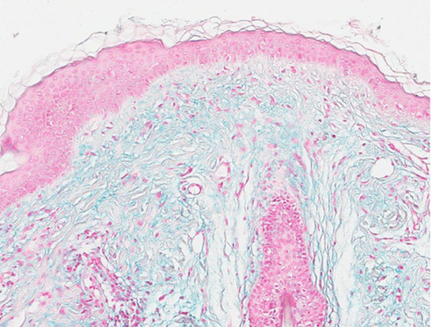

图示：真皮间质粘蛋白沉积（Alcian Blue染色）

产品仅供科学研究 严禁用于临床诊断
For Research Use Only. Not For Use In Diagnostic Procedures.

